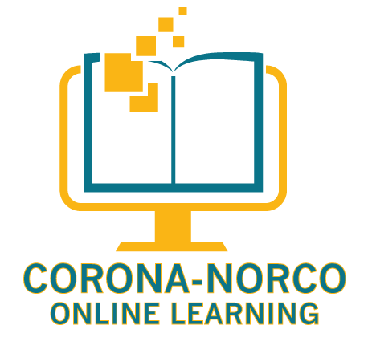
Welcome to CNUSD Online Learning for 2017-2018
Independent Study Online Students

Physical Education Activity Log

Your Independent Study PE teacher will be Mr. Pete Toomey. Mr. Toomey will be contacting you to discuss the various elements of your PE course and its curriculum.

Activity Log Instructions:

Record the activity time and description each time an activity is completed.
Return the signed log to Mr. Toomey; ptoomeyonline@gmail.com – on the last academic calendar day of the month.

ALL PE COURSES REQUIRE 240 MIN OF PHYSICAL ACTIVITY PER WEEK

ALL LOGS DUE AT THE END OF THE MONTH

